Note from the Chair: We would like to welcome you to the inaugural E&P Sound & Marine Life Programme newsletter. The purpose of this newsletter is to keep you abreast of the work and research of the International Oil and Gas Producers E&P Sound & Marine Life Joint Industry Programme (JIP). The JIP exists to promote scientific understanding, and therefore we hope this newsletter provides a useful way to access and promote the research of the JIP and the library of information on our website.
Paul Shone, Chair of the E&P Sound & Marine Life JIP

THE JIP: World’s largest non-governmental research funder
The JIP is a partnership of oil and gas producing companies, the International Association of Geophysical Contractors (IAGC) and the International Oil and Gas Producers (IOGP) to support research and help increase understanding of the effect of sound, generated by oil and gas exploration and production activity on marine life. It was founded in 2005 and is the world’s largest non-governmental funder of research in this field. To date, the JIP has committed US $55 million, funding more than 70 contracted studies.
To advance understanding of the interaction between sound from oil and gas operations and marine life, the JIP identifies and commissions research to:
1. Support planning of E&P projects and risk assessments.
2. Provide the basis for appropriate operational measures that are protective of marine life.
3. Inform policy and regulatory development.
JIP research continues to play an important role in informing regulators and the scientific debate on E&P sound and marine fauna. To read more about the JIP, our external advisors research areas, please download our factsheet.

INFORMING THE DEBATE
UNDERSTANDING THE POTENTIAL IMPACT OF REPEATED EXPOSURE TO SEISMIC IMPULSES ON DOLPHIN HEARING
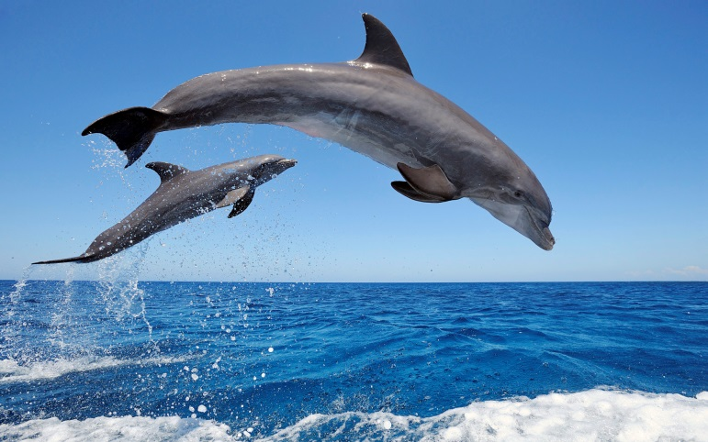
This independent research has helped to increase understanding of the potential temporary hearing impacts from seismic sound sources on bottlenose dolphins, and differentiate their impact from that of other sound sources such as sonars. Key findings from these studies include:
- Dolphins are relatively insensitive to seismic source impulses. This is primarily because seismic source impulses have mostly low-frequency energy and contain little energy at the high-frequencies where dolphin hearing is most sensitive.
- Behavioural responses to repeated impulses may reduce the levels of sound exposure by the ears, thus reducing the likelihood of temporary threshold shifts.
To read more about this research, please go to the website and download our factsheet.
PAMGUARD: FINDING AND TRACKING MARINE MAMMALS USING THEIR SOUNDS
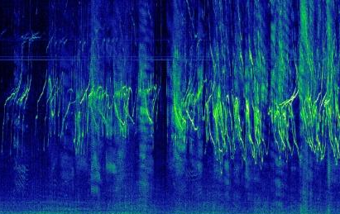
The JIP funded the development of a software tool called PAMGuard, designed to enhance Passive Acoustic Monitoring (PAM) of marine mammal sounds. PAMGuard has greatly advanced the use of passive acoustic monitoring for all those researching the behaviour of marine mammals, not just industry users. PamGuard benefits include:
- Provides a common tool for all those researching the occurrence and behaviour of marine mammals.
- Runs different vocalisation detectors simultaneously, allowing multiple species to be identified and potentially tracked at the same time.
- Enables the sharing of improvements with an expanding community of users, as an open source software tool that allows users to upgrade the system.
To read more about our work on PAMGuard, please download our factsheet.

ONGOING INDEPENDENT RESEARCH
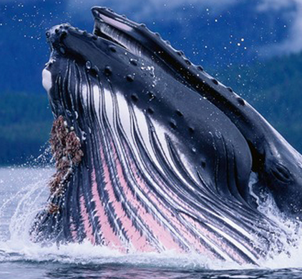
One of the vital roles of the JIP is administering and providing the financial support for independent research on global issues related to marine sound. Therefore, we issue new Requests for Proposals (RFPs) for specific projects or project areas around the JIP’s Research Topics of Interest.
New RFPs are published on the JIP website, and a list of active RFPs can be viewed here. Recent RFPs include:
- Improvements for Towed Passive Acoustic Monitoring (PAM) Technology
- Marine Mammal Observer / Protected Species Observer Data Analysis
PROMOTING THE SCIENCE
An important part of what the JIP does is sharing our research with the scientific community and amongst policy makers at key industry events and other forums. This year, the JIP has presented and/or sponsored:
The Gulf of Mexico Marine Mammal Research and Monitoring Meeting
More than one hundred people participated in the meeting, which examined recent and ongoing marine mammal projects in the Gulf.
A representative of the SML JIP gave a presentation providing an overview of the JIP and completed and ongoing research projects.
OCEANOISE 2015
OCEANOISE is a conference in Europe specifically focused on gaining more insight into the environmental impact of ocean noise at large spatial and temporal scales.
The JIP was well- at the conference. A SML JIP representative provided a presentation introducing the JIP and its research during a poster session. The JIP also had an exhibition stand where factsheets were disseminated.
169th Meeting of Acoustical Society of America
America’s scientific society examines all aspects of acoustics and acts as a forum for scientists and other international acoustic associations to discuss industry issues and share findings.
A representative of the SML JIP provided a presentation at this scientific conference.
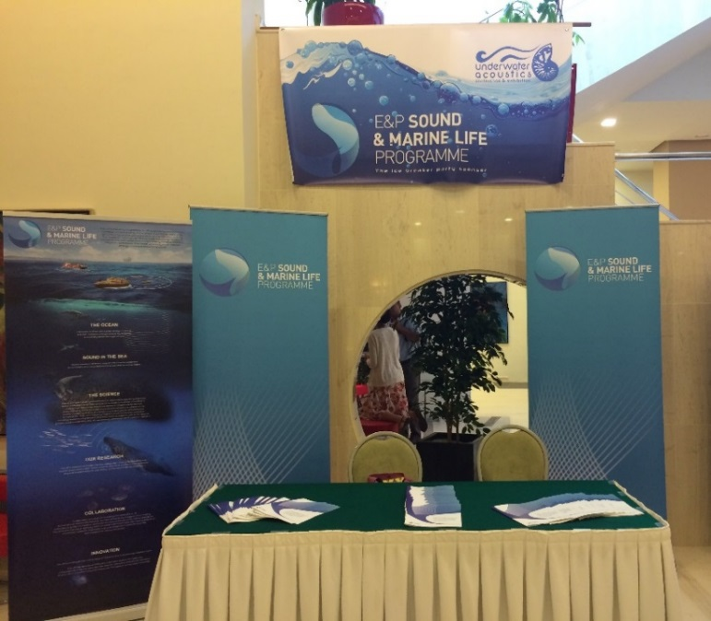
Underwater Acoustics Conference & Exhibition (UACE) 2015
The Underwater Acoustics Conference is an international conference examining specifically underwater acoustics and is attended by scientists and engineers from universities, research institutes, and government organisations.
The JIP sponsored the opening reception and gave a presentation. The JIP also had an exhibition stand where attendees could access reading material about the JIP. JIP sound source measurement data was cited by the Netherlands Organisation for Applied Scientific Research (TNO) because it has helped calibrate their seismic source modelling algorithm.
Society of Exploration Geophysicists (SEG) International Exposition and 85th Annual Meeting
The SEG Annual Meeting is the world's largest oil, energy and mineral exposition showcasing cutting-edge technology for use in exploration and associated industries. It is the premier venue for individuals to meet and discuss new geophysical technologies and their uses and features presentations of over 1000 abstracts as part of the technical programme.
A number of SML JIP representatives participated in a workshop dedicated to the discussion of Next Generation Marine Seismic Sources and in particular SML JIP work completed and planned for assessing the potential environmental effects of next generation Marine Vibrators.
13th-18th December - 21st Biennial Conference on the Biology of Marine Mammals
The Society for Marine Mammalogy biennial international meeting aims to enhance collaboration, sharing of ideas, and improve the quality of research on marine mammals. There will be over 1,000 poster presentations and topical workshops.
The JIP sponsored and exhibited at this important conference. The JIP abstract was also included in the book of abstracts. For more information on this conference, please go to the website.

